Task 1: Popular Wi-Fi Standards Comparison

- 802.11n (Wi-Fi 4):
  - Frequency & Speed Difference: Operates across both the 2.4 GHz and 5 GHz frequency bands, delivering maximum theoretical throughput of up to 600 Mbps by introducing MIMO (Multiple Input, Multiple Output) spatial streams.
- 802.11ac (Wi-Fi 5):
  - Frequency & Speed Difference: Operates exclusively on the 5 GHz band (relying on legacy standards for 2.4 GHz backwards compatibility), increasing channel widths up to 160 MHz to deliver data rates up to 6.9 Gbps.
- 802.11ax (Wi-Fi 6 / 6E):
  - Frequency & Speed Difference: Operates across 2.4 GHz, 5 GHz, and the expanded 6 GHz spectrum (Wi-Fi 6E), reaching theoretical speeds up to 9.6 Gbps and using OFDMA (Orthogonal Frequency-Division Multiple Access) to handle dense client environments efficiently.

Task 2: Smartphone to Internet Network Diagram

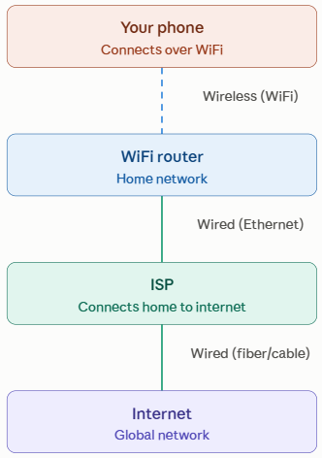
Wireless Segment: Connects the smartphone antenna
wirelessly to the home Wi-Fi router’s access point via
over-the-air radio frequency (RF) bands.
Wired Segment: Links the router to the ISP modem/ONT
via copper twisted-pair (Ethernet) or direct fiber, routing
out to the ISP distribution hub across physical optical
cables.

Task 3: Wi-Fi Network Scan & Selection Analysis

- Nearby Network Scan Results
SSID (Network Name) | Signal Strength (RSSI) | Security Standard | Frequency Band
Home_Fiber_5G | -48 dBm (Strong) | WPA3-Personal (SAE) | 5 GHz
Apt_204_Ext | -67 dBm (Moderate) | WPA2-Personal (AES) | 2.4 GHz
City_Public_Wi-Fi | -55 dBm (Good) | Open / None (Unencrypted) | 2.4 GHz / 5 GHz

- Selected Network & Justification
- Chosen Network: Home_Fiber_5G
- Reasoning:
  - Security: It enforces WPA3-Personal, utilizing Simultaneous Authentication of Equals (SAE) to eliminate offline dictionary attacks and protect ongoing sessions against credential interception. In contrast, City_Public_Wi-Fi offers no encryption, leaving traffic exposed to sniffing.
  - Signal Strength & Throughput: At -48 dBm, the signal is strong and stable (well above the typical -65 dBm cutoff required for seamless streaming and low ping). Combined with the 5 GHz band, it avoids the channel congestion common to 2.4 GHz networks.

Task 4: SSID hiding

SSID hiding means configuring your router to stop broadcasting its network name, so it won't appear in the list of available networks when someone scans for WiFi nearby. To connect, a device has to already know the exact SSID with password and type it in manually, rather than picking it from a visible list.
- Advantage: It keeps casual, non-technical users from noticing your network exists at all — a small deterrent against opportunistic neighbors trying to connect.
- Disadvantage: It's security through obscurity, not real security — the network is still detectable using basic WiFi scanning tools that pick up hidden SSIDs from probe requests. It also adds inconvenience: every new device has to be manually configured with the exact SSID and password instead of just selecting the network from a list, and some devices handle hidden networks poorly (slower reconnection, extra troubleshooting).

